- The number of labeled unrooted trees with n nodes is n ^{n−2}.
- The number of labeled rooted trees with n nodes is n ^{n−1}.
- Denote the number of unlabeled rooted trees with n nodes by a_{n}, then
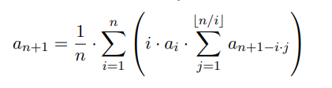
- Denote the number of unlabeled unrooted trees with n nodes by b_{n}.
If n is odd number, then
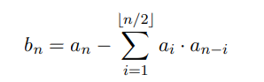

If n is even number, then
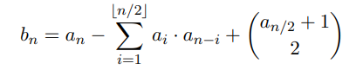
- The number of of labeled graphs 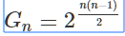
- Denote the number of connected labeled graphs with n vertices as C_{n}, then
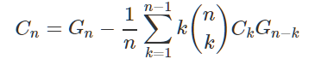
- The number of labeled graphs with k connected components.
We will compute D[i][j] - the number of labeled graphs with i vertices and j components - for each i≤n and j≤k.
